R&S SMW200A csv to XDW Python Script Instructions

Document Version 1.2
9/24/2026

Written by:
Luke Grantham
Application Engineer
Rohde & Schwarz USA
luke.grantham@rsa.rohde-schwarz.com
(619)930-6753


Contents
1 About 3
1.1 Purpose 3
1.2 Key Features 3
2 Getting Started 3
2.1 Required Components 3
2.2 What’s Included 3
2.3 Installation Instructions 4
2.3.1 Pip 4
2.3.2 Numpy 4
2.3.3 Rsxdwstreaming 4
2.3.4 Rskfd 5
2.4 Overview of Operation 5
2.5 References 5
3 CSV Structure 5
4 Workflow 7
4.1 Build a list of PDWs and TCDWs in .xlsx Format 7
4.2 Save to .csv 7
4.3 Run Python Script 7
4.4 Transfer Script Output Files to the SMW200A 9
4.5 Play the Files Using the Extended Sequencer 10
5 Q&A 14

About

Purpose
This script was created to convert .csv formatted Pulse Descriptor Word (PDWs) and Timed Control Descriptor Words (TCDWs) to a format that is readable by Rohde & Schwarz vector signal generators.
Descriptor Words are simple, readable structures that describe a pulse. R&S Pulse Descriptor Words (PDW) can be used to generate pulsed signals in real-time or replay pre-calculated waveform segments. R&S Timed Control Descriptor Words (TCDW) can be used to change instrument RF frequency and/or level or re-arm the Extended Sequencer.

Key Features
Customers provide a .csv with Descriptor Words with information describing a pulse. The script processes the .csv and generates the necessary files to output the pulses on the Rohde & Schwarz SMW200A Vector Signal Generator.

Getting Started

Required Components
On the PC running the script:
- Python: Version 3.12.3 was used during verification.
- rsxdwstreaming: the package file (wheel) for PDW Expert. Please reference installation instruction in Section 2.3 for more details.
- numpy version 1.26.3. It most likely will work with any version previous to 2.0, but the verified version is 1.26.3. Please reference installation instruction in Section 2.3 for more details.
  - Documentation: https://numpy.org/doc/1.26/
- rskfd: This is a tool for instrument and data handling in R&S formats. Please reference installation instruction in Section 2.3 for more details.
  - Documentation: https://pypi.org/project/rskfd/
On the SMW200A:
- Required:
  - SMW-B13XT — Wideband baseband main module
  - SMW-B9 — Wideband baseband generator (incl. ADV DATA/CTRL interface)
  - SMW-B10xx — RF frequency option, e.g. SMW-B1003
  - SMW-K502 — Wideband extended sequencing
  - SMW-K503 — Real-time control interface
  - SMW-K504 — Enhanced PDW rate and control PDWs
  - Firmware — 5.30.047.xx or later
- Optional:
  - SMW-B15 — Up to 4 processing boards, for up to 6 sequencers
  - SMW-K515 — ARB memory up to 2 GSamples, for large ARB container waveforms
  - SMW-B20xx — Second RF output
  - SMW-K315 – Pulse-on-pulse simulation for summing outputs of processing boards

What’s Included
Inside the folder attached, there are a few important files:
- PDWlist.csv and PDWlist_verif.csv– example csv files with PDWs and TCDWs.
  - PDWlist.csv contains arb PDWs.
  - PDWlist_verif.csv does not contain arb PDWs.
- xdw_file_playback.py – this is the script a user would run to generate the files needed for the import into the SMW200A. Running this script outputs the following files:
  - *.ps_def file contains the PDWs and TCDWs. This file is always generated.
  - *.ps_adr file contains the addresses of the waveform segments (addressed by PDWs). This file is generated when arb PDWs are included.
  - Pulse1.wv and Pulse2.wv are example waveform files used in the csv file for use with the ‘xdw_file_playback.py’ script to generate the container waveform ‘IQ_expert.wv’. This file is generated when arb PDWs are included.
- rsxdwstreaming-2.0.0-py2.py3-none-any.whl - is the package file (wheel) for PDW Expert
- Doc directory – Contains HTML formatted documentation for installation of the Rsxdwstreaming package

Installation Instructions

Pip
The Package Installer for Python (pip) is used to install the necessary packages for this script. If this is not installed on the PC system, please follow the instructions here: https://www.geeksforgeeks.org/how-to-install-pip-on-windows/

Numpy
Numpy is a package used by the script for numeric operations. Install Numpy using the “pip” command. Version 1.26.3 is verified to work with this version of the python script. Versions 2.0 and later will not work.
Run the following command in the command prompt.
>> python -m pip install numpy==1.26.3

PyQt6
PyQt6 is the package that enables the GUI.
Run the following command in the command prompt.
>> python -m pip install PyQt6

Rsxdwstreaming
The Rsxdwstreaming-2.0.0-py2.py3-none-any.whl package file (wheel) is for PDW Expert pulse building. This can be installed using the PIP command.

- Save the rsxdwstreaming package on your computer, for example in c:\temp\
- Start the command line WinKey + R, type cmd and hit ENTER
- Change the working directory to the Python installation of your choice (adjust the user name and python version in the path):
  - cd c:\Users\John\AppData\Local\Programs\Python\Python37\Scripts
- Install with the command: python -m pip install c:\temp\rsxdwstreaming-2.0.0-py2.py3-none-any.whl
Please see the doc/getting_started.html for more information on this package.

Rskfd
The package rskfd is for instrument and data handling. Data handling mainly focuses on reading and writing I/Q files in public R&S formats. To install this, please use pip
>> python -m pip install rskfd

Overview of Operation
The typical flow of operation would be as follows:
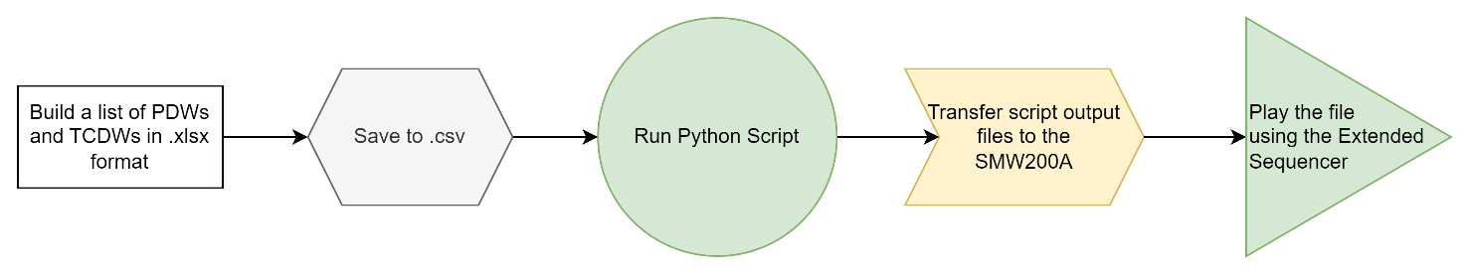

Figure 1: Typical Flow
Further details on each of these processes are described in Section 4.

References
SMW200A User Manual: https://scdn.rohde-schwarz.com/ur/pws/dl_downloads/dl_common_library/dl_manuals/gb_1/s/smw200a_1/SMW200A_UserManual_en_22.pdf
SMW200A K503 Extended Sequencer User Manual: https://www.rohde-schwarz.com/us/manual/r-s-smw200a-extended-sequencer-user-manual-manuals_78701-249480.html
K503/-K504 PDW and TCDW ICD: https://scdn.rohde-schwarz.com/ur/pws/dl_downloads/dl_application/application_notes/1gp133/ICD_PDW_TCDW_rev2.3.pdf

CSV Structure
The input to the script is a .csv with all the information about the PDWs and TCDWs.
The script searches for the following terms: Type, TOA, Mod, Arb, RF, Pulse Width, RF Freq, Level, Frequency Offset, Level Offset, Phase Offset, Freq Step, Chip Width, Bkr Code, Stuff, Burst PRI, Number of Pulses, Marker 1, Marker 2, and Marker 3. Columns that do not contain these terms will be ignored in the input file. Columns that contain these terms, but are not inputs to the script, might confuse the parser. For example, if you have a column titled “TOA (clicks)” that you use to calculate some intermediate values, the script might interpret that value as the TOA field.
Use as many columns as necessary for calculating values provided the naming convention is followed.
Note: An .xlsx file will typically be used to build the list of PDWs and TCDWs since the fields are typically calculated from other fields using formulas. Please save your file as a .csv for an input list. This is so the raw values (not formulas) are saved in each cell.
Column Descriptions
Column Label in .csv | Supported Values | Unit | Description
Type | tcdw, pdw | N/A | Control RF Parameters and generate pulsed signals.
TOA | See ICD | seconds | Timestamp relative to scenario start trigger event. To avoid dropping PDWs, please allow for adequate time for the previous PDW to complete.
Path | 0, 1 | N/A | Sets the desired RF path to configure TCDW types rffreq, rflevel, rffreqlevel  0 – configures RF path A  1 – configures RF path B
Mod | Rectangular,  Linear Chirp,  Tchirp,  Barker | N/A | In PDW, this is the type of pulse modulation.
RF | rffreq, rflevel, rffreqlevel, EOF | N/A | In TCDW, this specifies the type of TCDW. If ‘rffreqlevel’ is used, adjusting the RF frequency & level settings with a single TOA is possible. In this case, use ‘Level Offset (dB)’ column to enter the desired RF Level. If ‘EOF’ is used, the TOA marks the end of the scenario and sets the repetition interval for repeated playback.
Pulse Width |  | N/A | In PDW, this specifies the pulse width.
RF Freq | Instrument Specific | Hz | In TCDW, this specifies the center frequency of the modulation bandwidth. If a pulse is desired outside this bandwidth, a new TCDW with a new center frequency should be placed before the pulse is created. Please allow for 5ms settling time when modifying the frequency.
Level | Instrument Specific | dBm | In TCDW, this specifies the level of the instrument. When changing the level, please allow for 25ms settling time if the step attenuator is changed.
Frequency Offset | Instrument Specific | Hz | In PDW, the frequency offset is added to instrument RF frequency specified in the latest rffreq TCDW.
Level Offset | Instrument Specific | dBm | In PDW, the level offset is subtracted from instrument RF level specified in the latest rflevel TCDW. If using ‘rffreqlevel’ TCDW type, this column can be used to set RF level (follows same settling time guidelines as ‘Level’ column)
Phase Offset | 0 - 360 | Degrees | In PDW, this is the phase offset
Freq Step | Instrument Specific | Hz/Sample | In Linear Chirp PDW, this specifies the frequency step in Hz/Sample. This value is dependent on the instrument clock.
Chip Width | See ICD | N/A | In Bkr Code PDW, this specifies the chip width of one Barker code chip
Bkr Code | 0-8 | N/A | In Bkr Code PDW, this is the code to select the type of Barker code.
Stuff | See ICD | N/A | Stuffing bits
Burst PRI | See ICD | seconds | In PDW, this is the Pulse Repetition Interval for burst
Number of Pulses | See ICD | N/A | In PDW, this is the total number of pulses for the PDW
Marker 1 | 1 or 0 | N/A | In PDW, this activates Marker 1 on the specified pulse.
Marker 2 | 1 or 0 | N/A | In PDW, this activates Marker 2 on the specified pulse.
Marker 3 | 1 or 0 | N/A | In PDW, this activates Marker 3 on the specified pulse.

Please reference the included example .csv files PDWlist.csv and PDWlist_verif.csv
Note: Please ensure the last descriptor word in the list is an EOF (End of File) TCDW. This is vital for synchronization. The TOA of the EOF marks the end of the scenario and sets the repetition interval for repeated playback, so it should be at or after the end of the last pulse.

Workflow

Build a list of PDWs and TCDWs in .xlsx Format
The first step in the process is to build a list of PDWs and TCDWs. This is typically done in .xlsx format so formulas can be leveraged for calculating various values such as TOAs. The .csv format can be used, but the Excel formulas will not be supported.
Each line in the .xlsx represents a pulse with a number of repetitions based on the “Number of Pulses” field.
All timing for the PDWs is based on the TOA (Time of Arrival) field. To avoid dropping PDWs, please allow for adequate time for the previous PDW to complete.
The last descriptor word in the file should be an EOF (End of File) TCDW. This ensures synchronization and terminates the list.
Note: If you do not have an EOF TCDW as your last descriptor word, one will be appended by the script at the time the last pulse ends. If the EOF TOA is earlier than the end of the last pulse, the script logs a warning because playback would be cut short. However, it is best practice to have this included in the file.
Please reference Section 3 for further details about the column descriptions and the included .csv files for examples.

Save to .csv
The script needs comma separated text as an input. It does not support the more complex file format of .xlsx. Please treat the .xlsx as your master file and save a copy as .csv to feed into the script.

Run Python Script
Run Command Prompt in the python_package_xDW_SMW200A directory by right clicking and selecting “Open in Terminal”
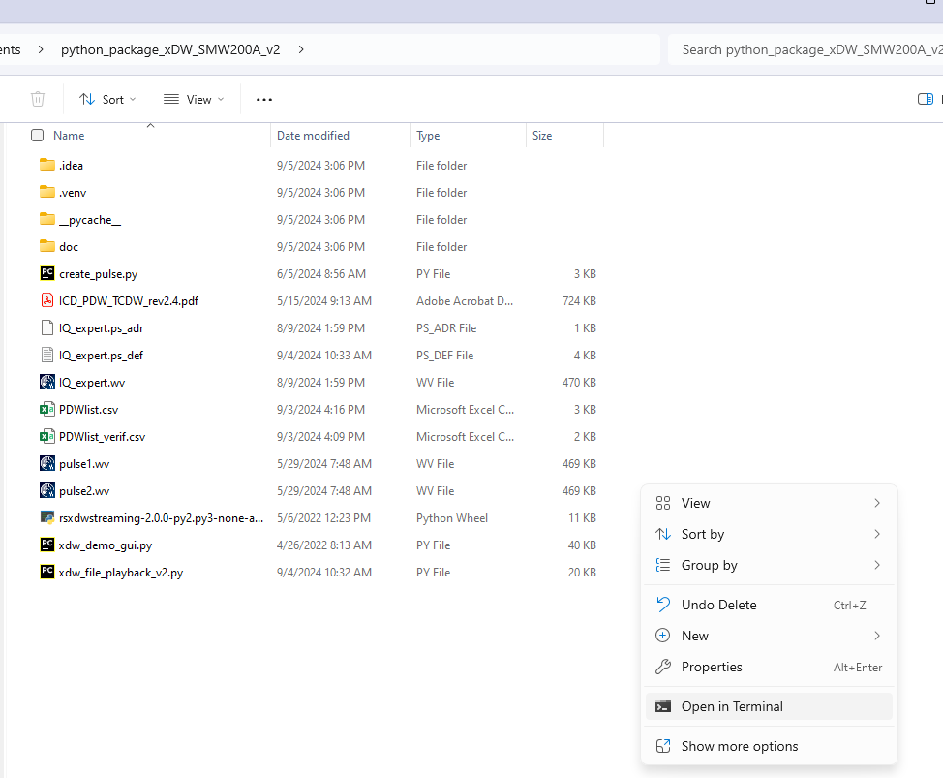

Run the Python script:
>> python xdw_file_playback.py
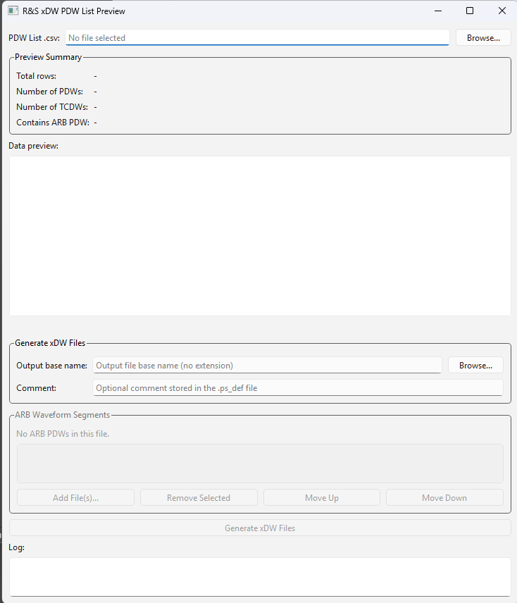

Select the .csv file using the path or Browse button.
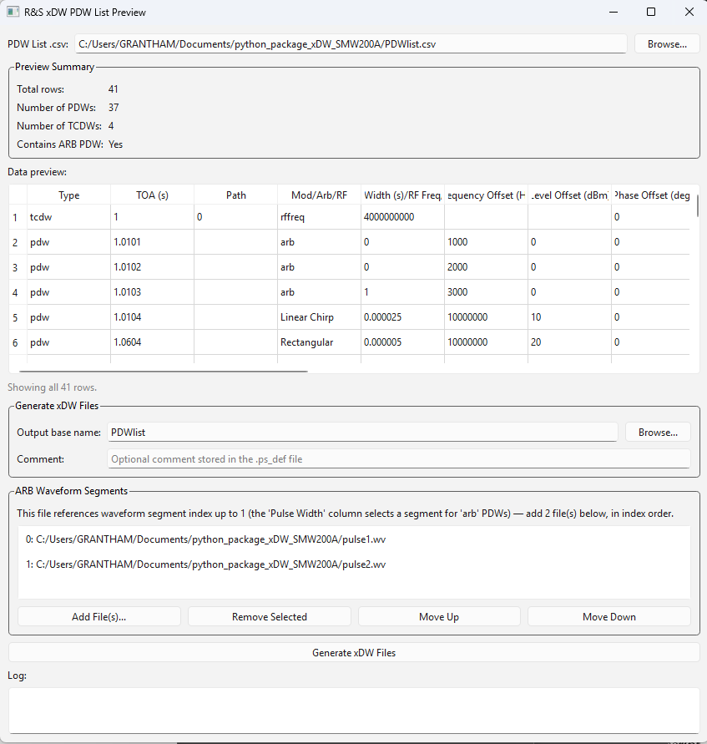
The Preview Summary shows information about the PDWs/TCDWs contained in the .csv.
Data preview lets the user scroll through the PDWs/TCDWs to ensure the tool has parsed the data correctly.
Generate xDW Files determines the output file names and an optional comment for user tracking purposes.
The ARB Waveform Segments section is used when the .csv contains PDWs that play ARB segments. In the window, we can select the segments and align them with their index from the .csv
When ready, click the “Generate xDW Files” button. The Log has information on the processed PDWs and output of the system. A window will appear to notify the user of successful completion.
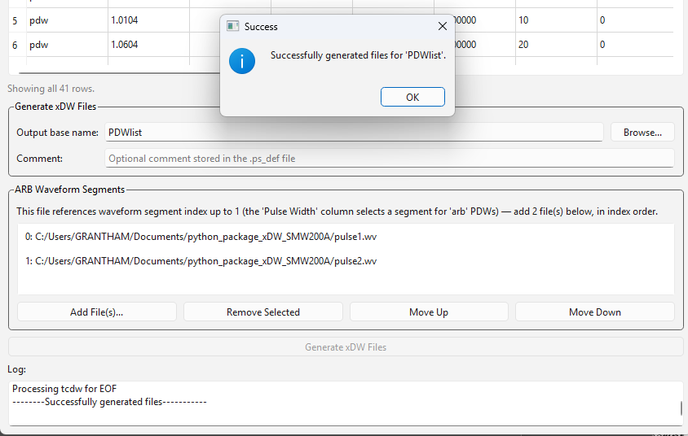

When using arb waveform PDWs, three files are generated based on the Output base name.
- *.ps_def file contains the PDWs and TCDWs.
- *.ps_adr file contains the addresses of the waveform segments (addressed by PDWs). This file is generated when arb PDWs are included.
- *.wv. This file is generated when arb PDWs are included.
When not using arb waveform PDWs, only *.ps_def file is generated.

Transfer Script Output Files to the SMW200A
There are multiple ways to transfer files to and from the instrument. The FTP method was used here.
Type “ftp://<ip address>” in the Windows Explorer window.
Type the username and password. Both are “instrument”
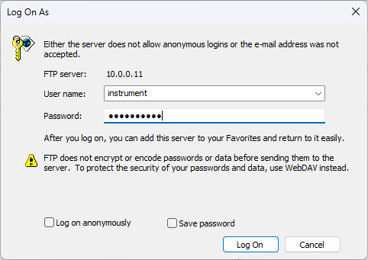

Copy and paste the three generated files under the “user” folder.
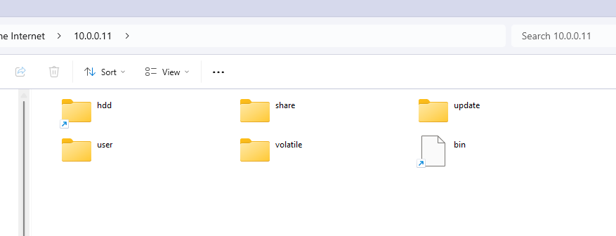
More methods and information can be found in the SMW200A User Manual https://scdn.rohde-schwarz.com/ur/pws/dl_downloads/dl_common_library/dl_manuals/gb_1/s/smw200a_1/SMW200A_UserManual_en_22.pdf

Play the Files Using the Extended Sequencer
To play the file back, it is recommended to start from a PRESET.
- Navigate to the “Baseband” -> “Extended Sequencer”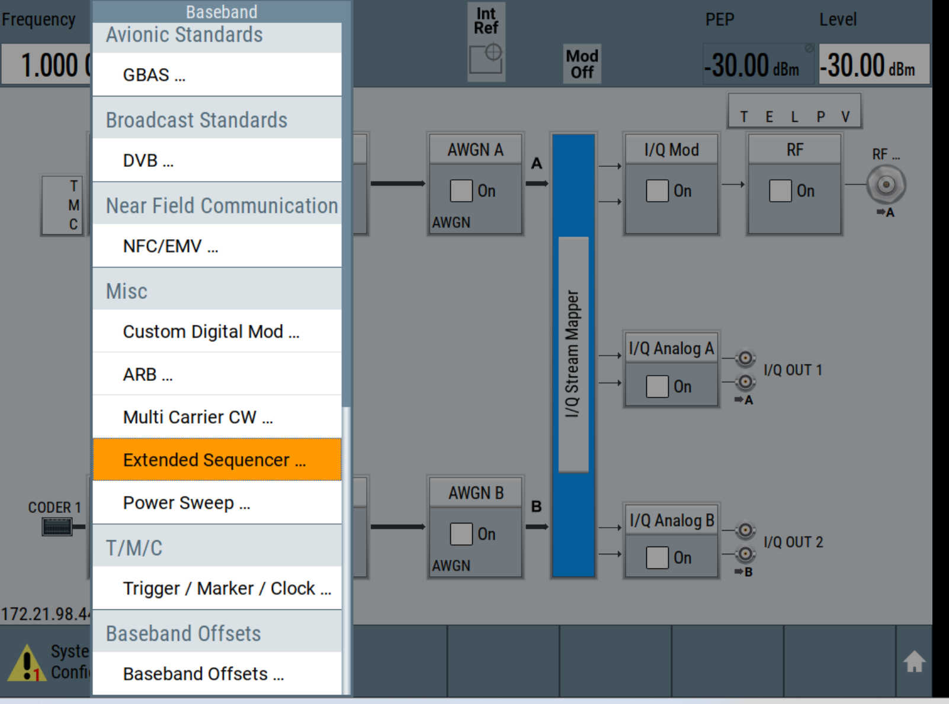
- Under “Mode”, select “Playback from File”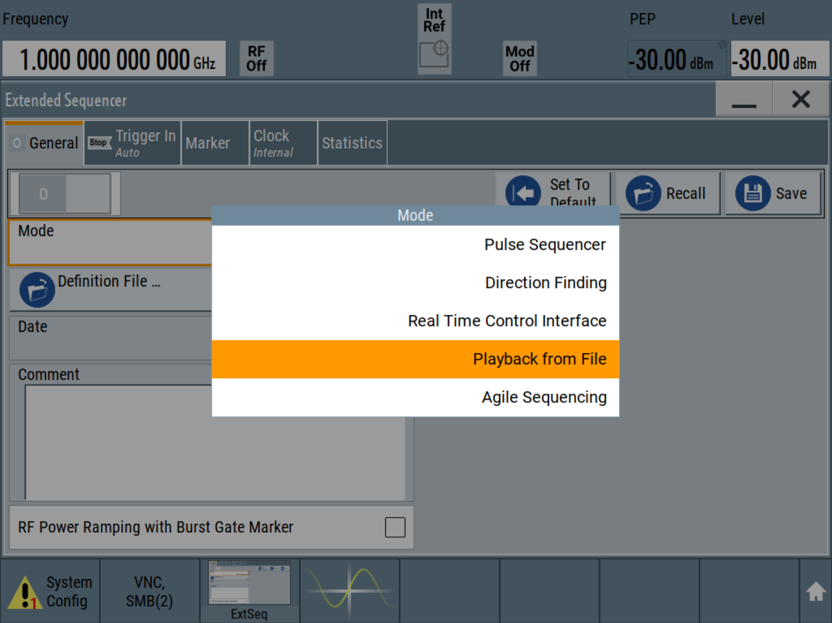
- Next, press “Definition File” and navigate to the “IQ_expert.ps_def” file.
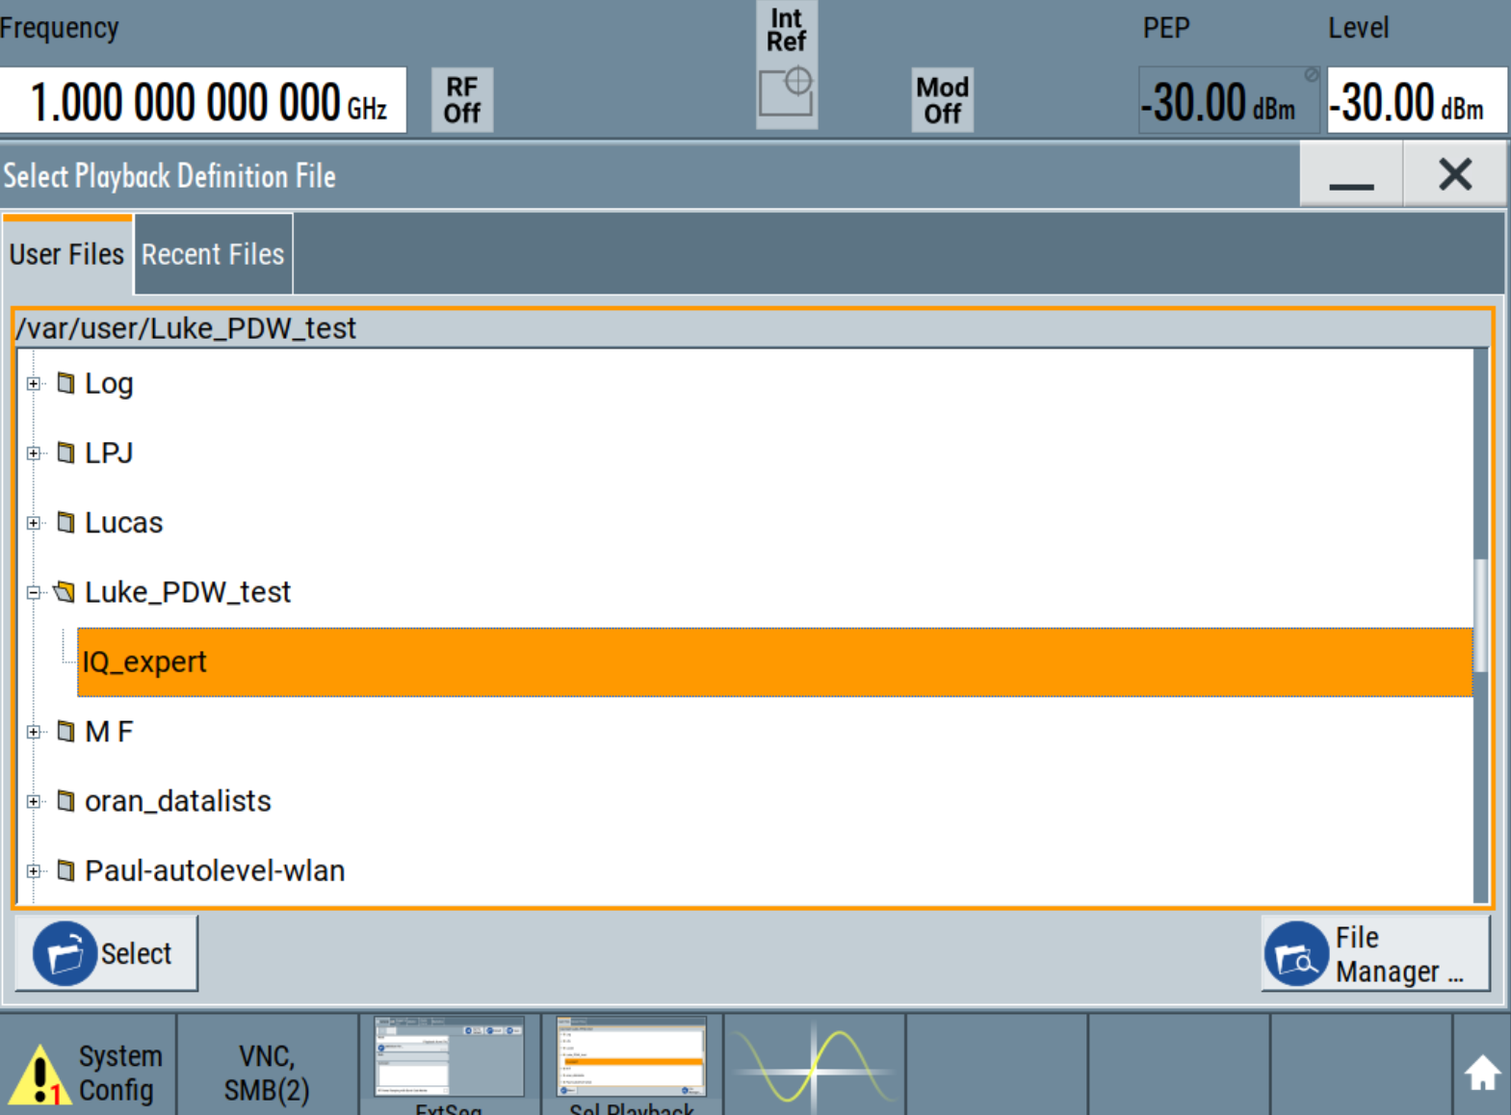
- Go to “Trigger In” tab and select the desired trigger method
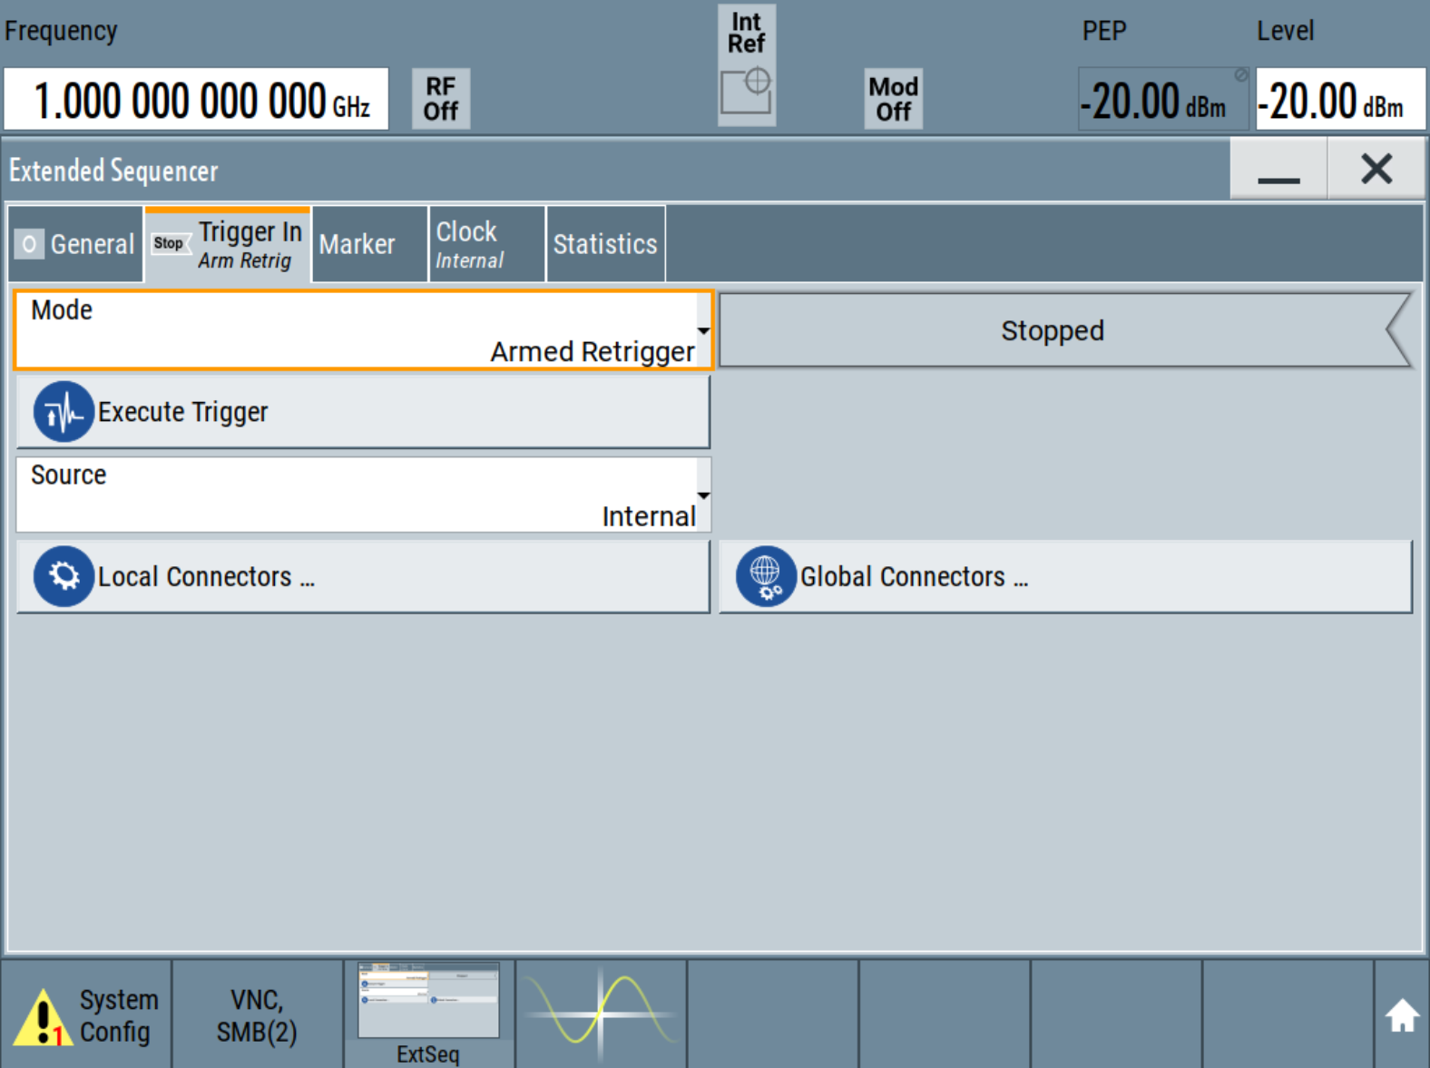
- Go to the “Marker” tab and ensure every marker type is selected to PDW. This ensures the SMW200A scans the incoming PDWs for Markers. The default selection is “Restart”.
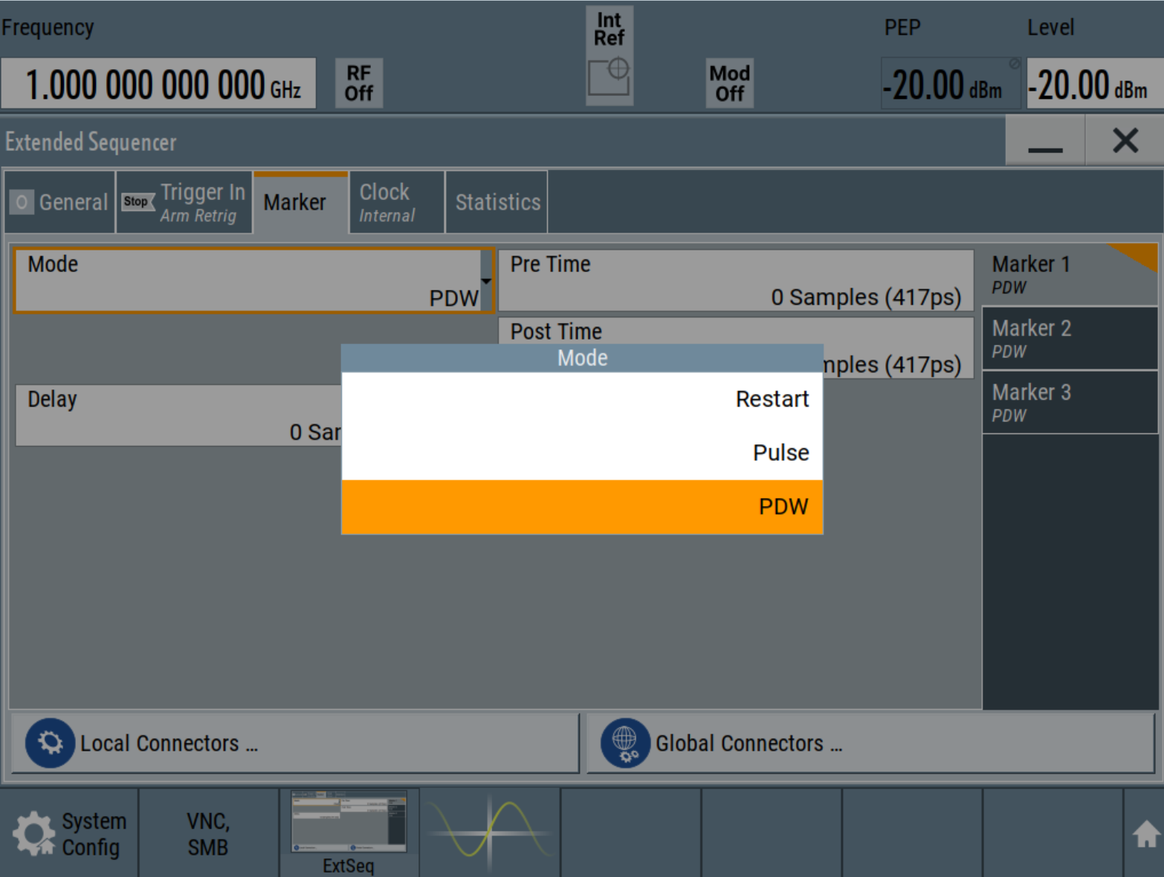
- Turn “RF On”
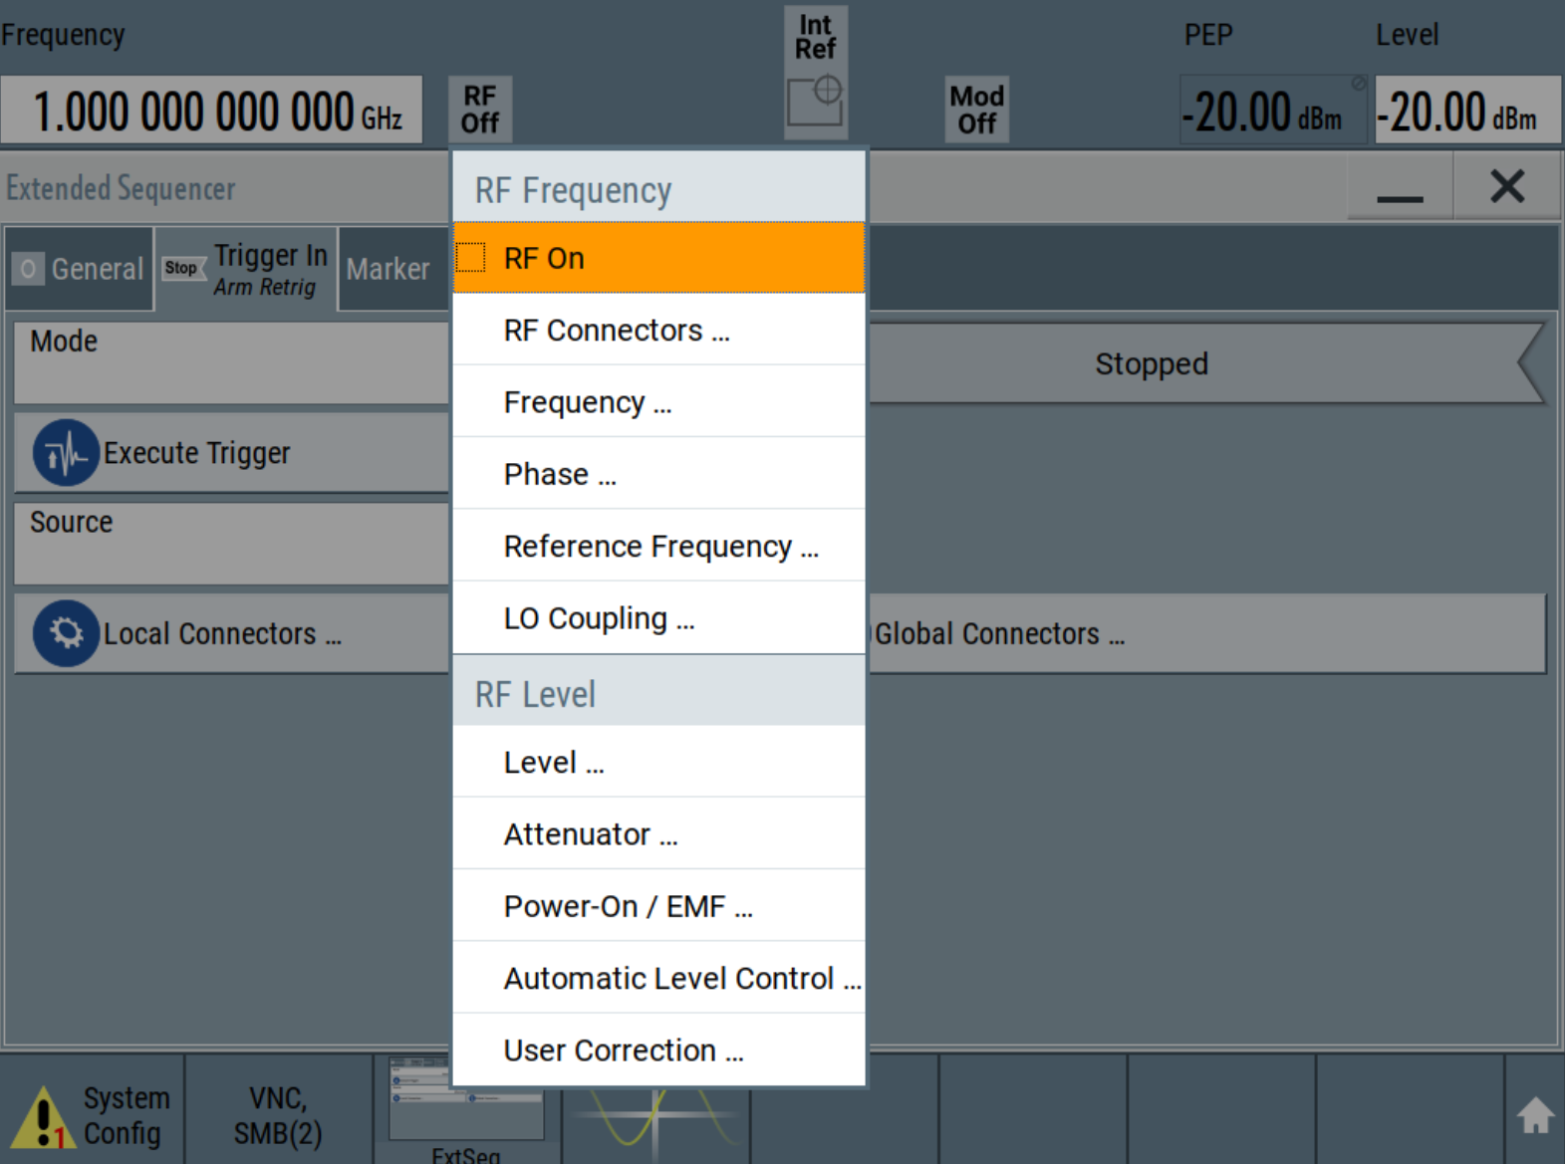
- Under the “General” tab, turn ON Extended Sequencer
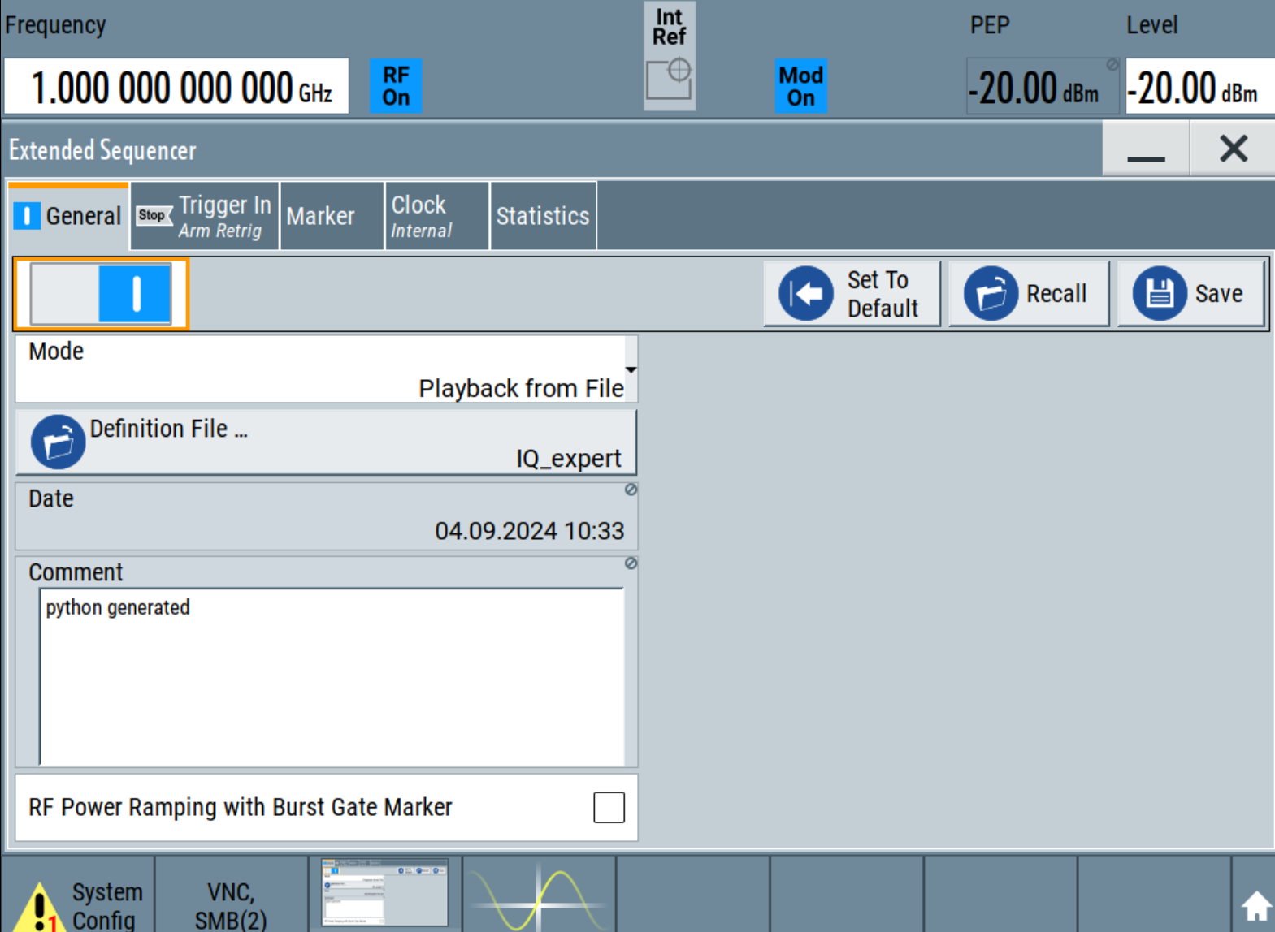
- Under “Trigger In” tab, Select “Execute Trigger” (if in Armed Retrigger Mode),
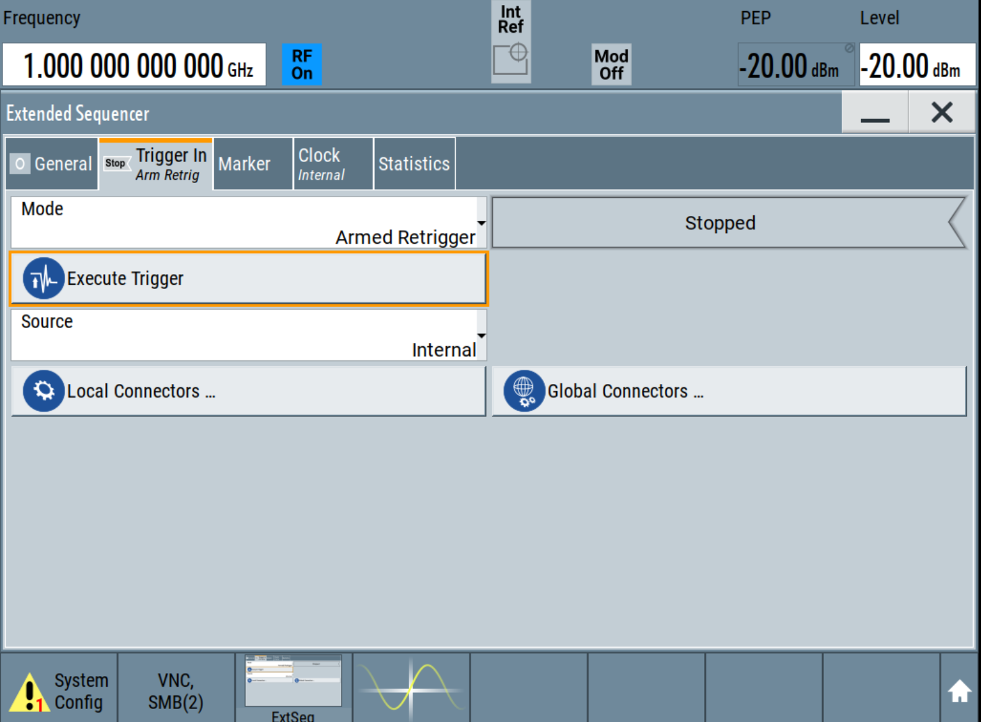

Optional Capabilities

Extended Sequencer Advanced
This allows for multiple files to be loaded onto different hardware resources. A sequencer is a unit of resource. There are up to 6 supported sequencers determined by the hardware configuration. A B9 or B15 option constitutes one sequencer.
The GUI has a tab to upload separate files to each sequencer. The outputs can be directed to RF A or RF B. If more than one sequencer is directed to one RF port, the outputs are summed. This allows for pulse-on-pulse modulation (provided the SMW is equipped with the K315 option).
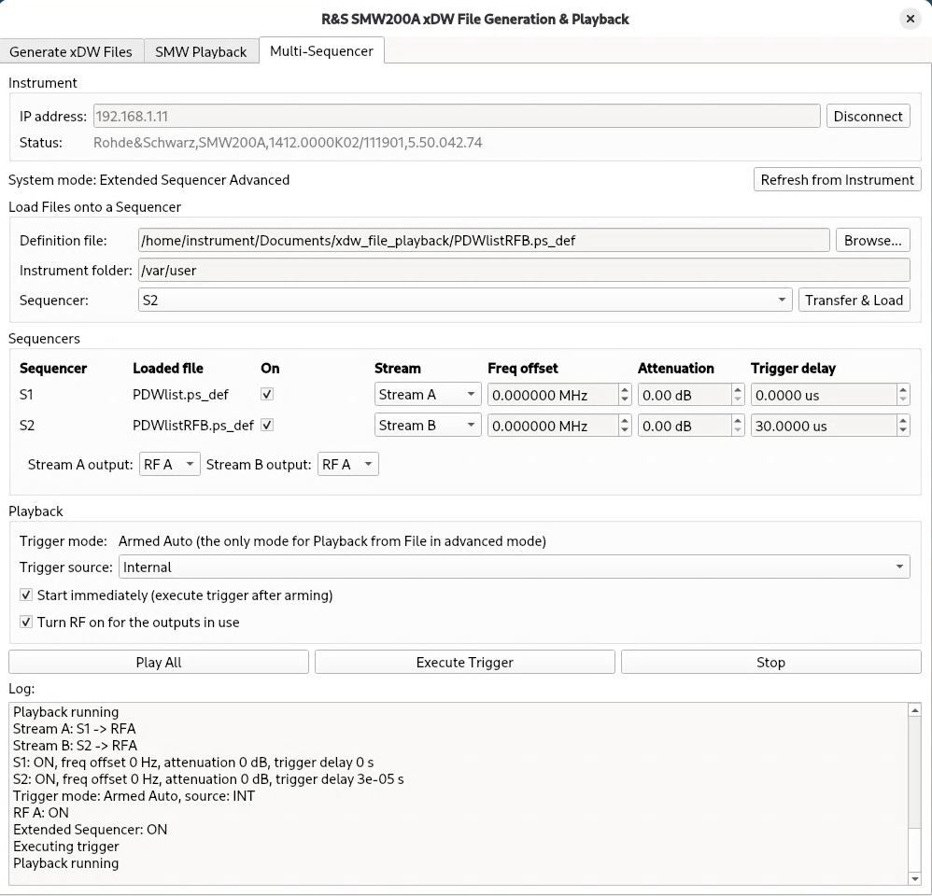
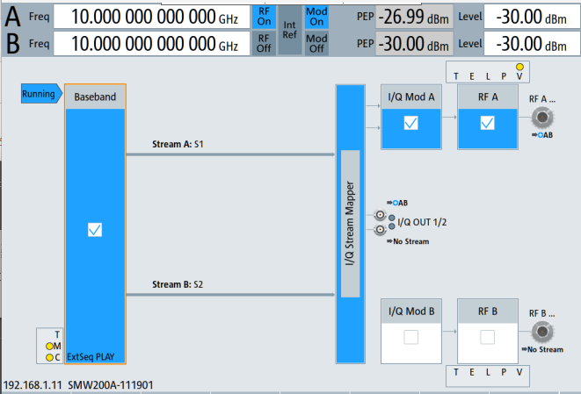
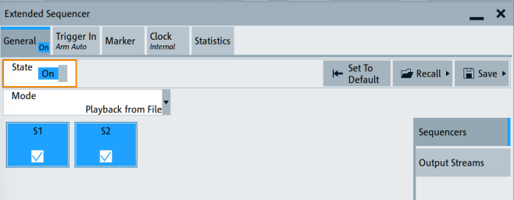

Q&A
TODO

